AL-RH215

5.0MP POE Network Full Color Metal Bullet 1-Way Audio Camera

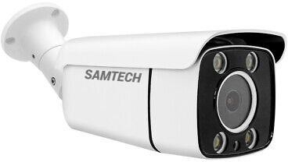





|  |  |
| --- | --- |
| Model Number | AL-RH215 |
| **Camera** | |
| Image Sensor | 1/2.8" SONY color CMOS |
| Min. Illumination | Color: 0.01Lux @F1.2, B/W: 0Lux with IR on |
| Lens | 4mm,6mm,8mm lens |
| Shutter Time | Auto |
| IR Distance | 80m |
| IR Board | 4pcs IR array LEDS |
| White Balance | Auto / Manual |
| AGC | Auto |
| WDR | Digital WDR |
| DNR | 2D/3D DNR |
| BLC | support |
| HLC | support |

|  |  |
| --- | --- |
| **Video** | |
| Max. Image Resolution | 5MP(2880*1620)@20fps |
| Frame Rate | Main code stream: 5MP@20fps,3MP@25fps,1920P/1080P@30fps  Auxiliary stream: D1/VGA/640x352/CIF@25fps |
| Video Compression | H265+/H265/H264 |
| Video Bit Rate | 500Kbps-4000Kbps support self-adjustable as needed |
| Image Settings | Brightness, Contrast, Saturation, Exposure, Upside Down, Mirror Adjustable |
| Bit Superposition | Support OSD name, time and date information superposition |
| Web Access | Internet explorer 6.0 and above (Web Server embedded in device) browser |
| **Audio** | |
| Audio I/O | No |
| Audio Compression | G.711 |
| **Network** | |
| Network Interface | 1*RJ45 10M/100M Ethernet Port |
| Networking Protocol | TCP/IP, HTTP,RTSP,DHCP,NTP,UPNP |
| ONVIF | ONVIF2.6 |
| APP | Support android, IOS |
| PC | Support |
| **System** | |
| Alarm I/O | Motion detection alarm |
| Storage | No |
| Motion Detection | 22*18 windows motion detection areas can be setting(sensitivity setting  1-100) |
| Human Detection | Yes |
| Video Mask | Support |
| Action with Alarm | Push to mobile APP |
| **General** | |
| Language Support | CHN(S)/CHN(T)/ENG |
| POE | IEEE802.3af |
| Power Supply | DC12V±10% / POE |
| Power Consumption | Max 5W |
| Lightning Protection | 2KV |
| Housing | Metal Bullet |
| Weather Proof | IP67 |
| Working Temperature | -30 °C to 85 °C |
| Working Humidity | 10%-95% (Non-condensing) |